# University of Notre Dame | Booz Allen Hamilton

# Master of Science in Business Analytics – Capstone Project

# Data Driven Human Performance

## Piloting an Analytics Focused Human Performance Paradigm for DoD Mission Operations

# November 2020

# Index

1. Executive Summary
2. Introduction
3. Group Members and Project Scope
4. Current Processes and Identified Pain Points
5. Solutions Implemented
6. Immediate Next Steps
7. Vision for the Future
8. Appendix

A. Current State Process Map

B. Actions and AWS Lambda/AWS API Gateway

C. Power BI Data Model Tables

D. PAX Dashboard

E. Scorecard

F. Coaches Survey Qualtrics Matrix Format

VIIII. Supplementary Materials

1. Data Dictionary
2. SQL Creation Code
3. RAG Logic Calculations

## Executive Summary

Booz Allen Hamilton has engaged students in the Notre Dame Master of Science in Business Analytics (MSBA) program to assess and make recommendations to improve its current Tactical Athlete Paradigm (TAP) program. The findings and recommendations summarized below were developed during a 12-week capstone engagement.

**Finding #1:** The TAP program is composed of several qualitative and quantitative surveys and assessments gathered from program participants at different stages in their training. As such, each component is delivered to participants using a different tool, and the results from each test section are stored in different platforms. This creates a disparate environment that makes it difficult to perform data aggregation for meaningful analytics.

To address this initial challenge, the MSBA team developed two customized data entry platforms in Qualtrics XM, each geared towards separate data collection efforts by coaches and participants, respectively. Implementing a single data entry platform to pipeline raw data is the first step in developing a scalable program that can produce meaningful analytics.

Moving forward, the MSBA team recommends that Booz Allen review the current process established to manage the cognitive portion of the TAP program. The different components of the cognitive test are performed, processed, and gathered in different platforms. This environment makes it difficult to scale the TAP program for a bigger audience.

**Finding #2:** Currently, coaches in the field are manually feeding a master spreadsheet on an ad-hoc basis with output from multiple other tools. The current structure heightens the risk of data entry errors, inconsistent formatting, and accidental data altering and loss.

To address this challenge, the MSBA team created a SQL database with direct integration into Qualtrics XM. Creating a centralized data repository ensures that data is captured and stored in an organized, transferrable, and sustainable environment moving forward. This step is critical to develop a scalable framework to ingest human performance data.

Although the MSBA team effectively removed the use of paper forms and centralized data collection for many of the TAP components, the data entry platforms developed for the capstone are not the original source of data. Moving forward, we recommend that Booz Allen integrate all the wearable technologies used in the TAP with the SQL database developed for this program to streamline the collection of data.

**Finding #3:** To assess and interpret participants’ performance in the program, coaches make use of a heavily customized scorecard in Excel. However, the current scorecard only measures performance on an individual basis and does not provide coaches with aggregated results to understand how groups are performing. This challenge severely limits coaches’ ability to quantify the success of the TAP program as a viable service offering.

To help coaches quantify the success of the TAP program, the MSBA team developed an improved participant scorecard and created a new group scorecard for descriptive analytics. However, due to the capstone engagement starting in parallel with the TAP pilot program, there is not enough available data to produce predictive and prescriptive models that can be replicated for further iterations. Moving forward, we recommend that the Booz Allen data science team applies regression and classification methods leveraging all the data generated by the different wearable technologies used by participants.

## Introduction

Continuing its commitment to advancing the field of data science, Booz Allen partnered with the University of Notre Dame to sponsor a capstone project focused on human performance analytics. Booz Allen has been tasked by a Department of Defense (DoD) client to pilot its Tactical Athlete Paradigm, a twelve-month program centered on the collection and analysis of human performance data drawn from qualitative surveys, training and fitness assessments, mission performance, and wearable sensors.

Booz Allen has tasked the MSBA student team to:

* 1. Assist in the execution of the data collection and analysis components of the pilot program.
  2. Provide strategic assessments and guidance for the future direction of the pilot program.

## Group Members and Project Scope

The following MSBA students were tasked to lead the Human Performance project:

|  |  |  |
| --- | --- | --- |
| **Name** | **Company** | **Role** |
| Joey Babyar | Rizing HCM | Project Manager |
| Angela Stitsworth | Beacon Health System | Digital Design & Customer Experience Analyst |
| Jaime Sanchez Alba | University of Notre Dame | Strategic Initiatives Analyst |
| Brian Rycyna | E78 Partners | Senior Associate |
| Claire Kozak | GATX | Chemical Engineer |
| Zachary Boiskin | Protiviti Inc. | Data & Analytics Consultant |

To provide guidance and subject matter expertise, Booz Allen selected a working group represented by:

|  |  |  |
| --- | --- | --- |
| **Name** | **MSBA Role** | **Professional Role** |
| Kevin Vigilante | Executive Sponsor | Chief Medical Officer and Executive Vice President |
| Cutter Brenton | Analytics Lead | Principal |
| JC Sullivan | Primary POC Analytics – Data Science | Associate |
| Matt Habrowski | Analytics – Data Science | Associate |
| Colin Friedman | Analytics – Data Science | Associate |
| Dom Angelotti | Analytics – Data Science | Senior Consultant |
| Laurel McKenzie | Human Performance SME | “Client” |
| MR Blank | Human Performance SME | “Client” |

As a client-centered firm, Booz Allen is committed to create value to its clients. As such, Booz Allen hopes to demonstrate the value proposition of this TAP program by:

* Creating operational efficiencies and analytic value add in the short term
* Building incremental progress towards a clear vision for longer term goals in a mission-oriented organization.

During initial conversations between the MSBA team and Booz Allen, the following project goals were established:

* 1. Construct a data ingestion framework to channel human performance data into an analytic environment.
  2. Leverage data gathered throughout the pilot effort to design case driven, modulated human performance analytics.
  3. Provide strategic assessments and recommendations for the future direction of the program.

## Current Processes and Identified Pain Points

The MSBA team started by seeking to understand how Booz Allen is currently operating its TAP program. The TAP program is composed of several qualitative and quantitative surveys and assessments gathered from each participant at different stages in their training. The graph below lists each section and the components that make up the TAP data analytic environment.

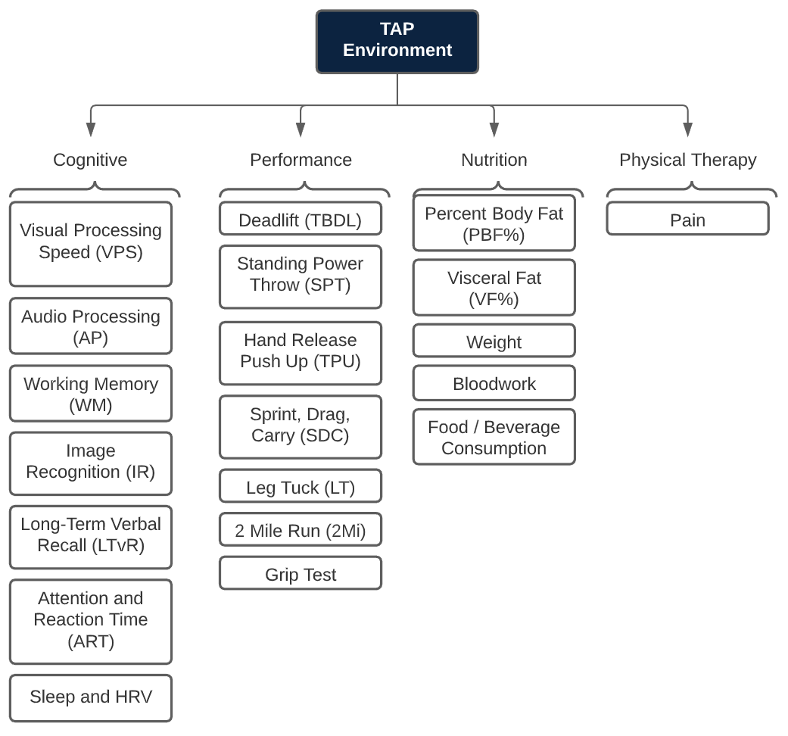

Figure 1 Test sections and components of the TAP environment.

Because of the initial time sensitive nature of the pilot program and the security-centric culture of the DoD, the Booz Allen team had limited time and resources to develop a working process for data ingestion and participant engagement. As such, each component is delivered to participants using a different tool, and the results from each test section are stored in different platforms. Additionally, because Booz Allen subject matter experts cannot directly store human performance data in an unclassified environment, they have relied on Microsoft Excel as their main platform for data capture and processing, manually transcribing test results to a master datasheet. This creates a disparate environment that makes it difficult to perform data aggregation for meaningful analytics. To develop a solid understanding of the current data gathering process, the MSBA team organized weekly calls with Booz Allen subject matter experts to develop a comprehensive list of data points gathered throughout the TAP program. Please refer to Appendix A for a complete current state process map.

Ultimately, the key objective of Booz Allen is to quantify the success of its pilot program, measured not only by participant satisfaction but also by presenting measurable improvement in key human performance metrics. These improvements are measured both on an individual and group level.

The MSBA team identified the following pain points as a baseline to develop and implement a set of solutions that will maximize value for Booz Allen and lay the foundation for future recommendations to further improve the TAP program.

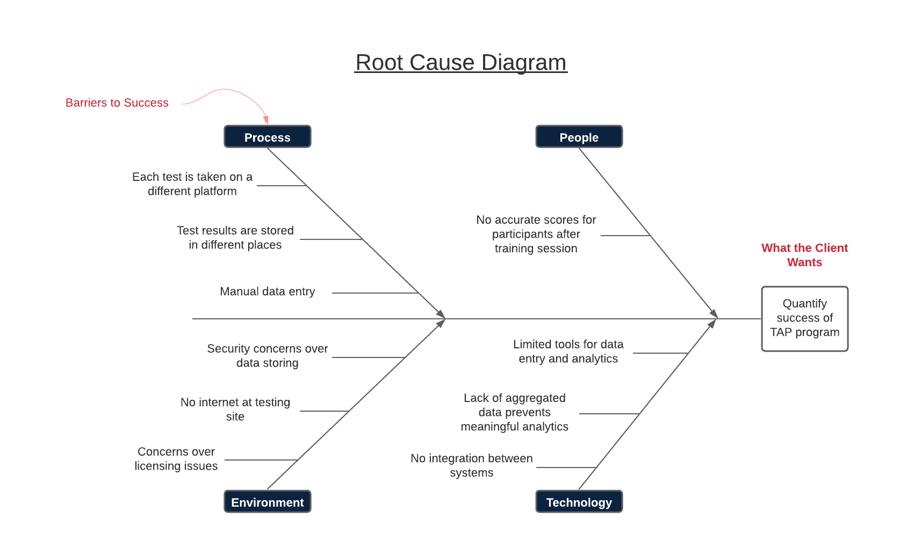

Figure 2 Identified pain points preventing measurable success of TAP program.

## Solutions Implemented

The MSBA team implemented the following solutions to deliver the project goals defined by Booz Allen. The effort was heavily focused on developing a framework to ingest human performance data to create an analytic environment that Booz Allen can continue to utilize as more data is generated.

### Solution #1: Develop a Solution for Raw Data Consumption

The MSBA team was tasked with creating a data entry system that centralized collection efforts, eliminated potential transcription errors, and achieved a seamless end-user experience. The team leveraged Qualtrics XM, an industry recognized platform in survey creation and data collection. Although several form building tools were assessed, Qualtrics XM was chosen because of its offline capabilities since several data entry points are completed in an offline environment. The MSBA team developed two customized data entry platforms, each geared towards separate data collection efforts by coaches and participants, respectively.

* The coaches survey, filled out by coaches, is designed to ingest data from the Elite HRV app, bloodwork panel, InBody test results, Bridge Athletic app, cognitive test summarized results and overall utilization of the program for each participant. (https://nd.qualtrics.com/jfe/form/SV_agd2GnTpeiqKsU5)
* The participants (PAX) survey, filled out by participants, is designed to ingest participant-derived baseline data both prior to and after completion of the TAP program. (https://nd.qualtrics.com/jfe/form/SV_3xZbfX35E1WrBWJ)

The Coaches Survey allows coaches, dietitians, and other DoD stakeholders to directly enter participant data from Elite HRV, Blood Work, InBody, Physical, Cognitive and Utilization tests. Data is entered using a non-identifiable participant ID number (PAX ID) which can then be used by the DoD team to identify participants once data and results are transferred into a classified environment.

Currently, data is collected in disparate systems and processes and ultimately re-entered manually in a master Excel workbook. The goal of implementing a revised entry platform is to streamline processes and preserve valuable skilled resource time and efforts for more programmatic tasks.

Because data entry is completed at intermittent dates and times throughout the program, including pre-testing, post-testing and testing at differing cadence, question blocks were created for each test type. This allows coaches to enter survey responses to different tests (Elite HRV, Blood Work, InBody Test, Physical, Cognitive & Utilization) either in one session or separately depending on specific needs and/or timing.

A table of contents is included in the survey flow to give respondents the ability to navigate between question blocks as needed. Questions are formatted to include content validation, reducing the potential for transcription errors, and eliminating back-end issues with incorrect data types (such as numerical responses entered as categorical). This step additionally allows for the application of advanced statistical methods in later project stages. Forced response validation is added as an additional layer to ensure respondents cannot skip any questions within the specific survey block which they are completing.

The PAX survey is given to participants at the start and end of the program to collect lifestyle and health-related data. Currently, these survey questions are directly transcribed from a paper form which participants print, fill out, and fax back to the dietician. In Qualtrics XM, each question is created with forced responses so that participants cannot skip any questions. Additionally, content validation is used for free text questions to ensure that responses are reasonable and properly formatted for database import. Upon completion of each PAX survey, an email trigger is in place to send all coaches an email notifying them that a participant has completed a survey and provides the selections made.

Implementing a centralized data entry platform reduces manual entry errors, reduces non-value-added time for coaches, and increases accuracy of granular data for further analysis. Using Qualtrics XM as a funnel for data gathering is the first step in developing a scalable program that can produce meaningful analytics.

### Solution #2: Create a Single Data Repository

Currently, data generated from participants are stored in different locations with different levels of granularity. Coaches in the field are feeding a master spreadsheet on an ad-hoc basis with output from other tools. The current structure provides the coaches with the flexibility to enter and correct participant data, but with the heightened risk of data entry errors, inconsistent formatting, and accidental data altering and loss. A data repository provides a secure environment with improved levels of data governance. The MSBA team integrated the input gathered from the Qualtrics XM surveys with a database hosted in SQL Server, effectively creating a robust, scalable framework to ingest human performance data.

The goal of creating a robust data repository is to ensure that data is captured and stored in an organized, transferrable, and sustainable environment moving forward. The database was structured with the following steps: schema, code, materialized. Each step was completed in sequence to ensure the data is accurately captured by Qualtrics and can be utilized for analysis in Power BI.

The first step of the process was to create the database schema, which can be thought of as the blueprint of the database. The blueprint ensured that each column of data from Qualtrics was captured and placed into the right table and each column was the correct data type. The schema was also purposed to diagram the relationships between each table through mutually shared columns, as an iterative process is much simpler in a schema environment than within the actual database. This process involved the creation of primary and foreign keys in layers to allow for multiple entries of the same unique personal identifier, the PAX ID. The primary key is a database auto-generated sequential number that identifies each unique survey entry. However, the database tables are related through a foreign key, PaxID, which identifies each unique participant. The combination of the auto-generated primary key along with the PaxID allows the entry of multiple results, such as pre and post test results, for each participant without violating the rule that a primary key indicator can only be used once. The database schema, as well as a data dictionary which contains an exhaustive list and definitions of the database variables and their relationships, are provided as supplementary material.

The second step was to code the database creation in a separate file outside of the SQL Server user interface. This step produced the actual code to create a physical database using T-SQL derived from the schema concept. The code was created in this environment to ensure that the syntax of creating a database was error free and acted as a layer of quality control to ensure all data types and columns were captured correctly. This also made it possible to transfer the database across servers. Correct, concise, and easily replicated code allows disparate parties to replicate the database in their own server environment regardless of the database server in which it was created. This ensures that the same database used in the test environment will also be used in practice. The database creation code is provided as supplementary material.

The final step was to materialize the database and test it for functionality. The code was run and then the database was loaded with test data to confirm all columns and data types matched the data schema. This process was iterated until confirmation that the database fulfilled its role as a storage and organization repository of data flowing from Qualtrics XM to Microsoft PowerBI.

### Solution #3: Develop Direct Data Ingest

To successfully push data from the surveys to the database, the MSBA team leveraged the use of another platform, Amazon Web Services (AWS). Within AWS, there is a serverless compute service, AWS Lambda, that allows code to be run in response to an event. For this project, the Lambda function leveraged the use of Python code. The Lambda function was written to push survey results from Qualtrics XM into the SQL database. For the code to be triggered, a web service request was created in the “actions” section of Qualtrics XM. Each action was designed to be event based, meaning once a survey, (or a portion of a survey, in the case of the Coaches Survey) is completed, the Lambda will make a call to the API (Application Programming Interface) gateway URL. This call runs the Python code in AWS Lambda, pushing the survey results into the database. Please refer to Appendix B for an example.

### Solution #4: Leverage Powerful, Flexible Business Intelligence Tools for Data Visualization

With a data ingestion framework in place, the MSBA team leveraged TAP program data provided by Booz Allen to produce multiple dashboards tailored towards specific audiences.

* An improved scorecard for participants’ consumption
* A PAX dashboard for an in-depth participant profile

The scorecard currently operates within Excel, and the MSBA team made several improvements as they transitioned it to the Power BI platform. A detailed discussion of these updates is in the next section of this report.

In the Power BI data model, the database tables are imported, as well as a “Name” table that is uploaded from Excel. This table functions as the primary key table to link the all the survey data from SQL with the PAX ID. This table also creates the ability to filter results using actual participant names tied to PAX ID when the scorecards are presented in a classified space without storing that identifiable information in the database. If the reports are being utilized in a non-classified space, dummy names should be used to populate the Name table. The Power BI data models for each dashboard are diagrammed in Appendix C.

The PAX dashboard is designed to visualize the results of the PAX survey and automatically calculate Red, Amber and Green (RAG) scores to remove this manual process from the coaches’ workload. The dashboard has three tabs. The first tab visualizes a single participant’s survey responses, grouped by RAG section. There are two dropdown filters for the coach to choose a PAX ID and Pre/Post survey to visualize. The background color of each RAG section is set to the respective RAG scores for the selected participant and changes dynamically based on the calculated RAG scores of the chosen PAX ID. The second tab visualizes all RAG scores of every PAX ID to provide the coaches with an at-a-glance summary. This visualization allows the coaches to quickly determine and summarize which participants, having red scores, need extra attention. Finally, the third tab provides a summary table of all participants’ survey response data to provide coaches with access to the complete dataset in tabular form. Screen captures of the three PAX dashboard tabs are shown in Appendix D.

There were two major barriers to address in the creation of the PAX dashboard. The first barrier was the implementation of the complex logic statements required to calculate the RAG scores. The Physical and Pain logic is straightforward and requires only one logic statement for each RAG score. However, the Nutrition and MPO RAG scores are an overall RAG score based on a majority rule of several individually calculated RAG scores, and so multi-step logic calculations are required to calculate the overall RAG score. The RAG logic statements are provided in the supplementary materials. The second barrier was slow dashboard reaction speed when changing the PAX ID in the dropdown. The first iteration of the dashboard had an average page load time of 4.9 seconds. Three changes were made to increase this time. First, in the original dashboard, each survey response with visualized individually with the Power BI “card” visual. While this format provides flexibility in visualization location, the large number of individual visualizations greatly slows down the page load time. Therefore, these were changed to tables that maintained the appearance of the page exactly as it was before. This change reduced the number of visualizations from 27 to 5 and reduced the average page load time from 4.9 to 1.9 seconds. Additionally, logic calculations were changed from nested IF statements to SWITCH statements, and calculations set up as Power BI measures were changed to calculated columns so that per-row calculations are performed upfront and not on-the-fly when the dropdown filter is changed.

### Solution # 5: Utilize Sound Statistical Methods for Meaningful, Actionable Insights

Currently, coaches make use of a heavily customized dashboard in Excel to interpret participants’ scoring results. This dashboard has been designed as a scorecard, and it summarizes several key metrics for coaches to drive a conversation on human performance assessment with their participants. However, the current scorecard only provides measures on an individual basis and does not provide coaches with aggregated results to understand how groups are performing. This challenge severely limits coaches’ ability to quantify the success of the TAP program as a viable service offering.

The MSBA team was tasked with answering several key questions. What are the benchmark statistics of human performance? Can those be measured within groups or against other participants. How can Booz Allen predict which participants will achieve better performance than others? What makes a change in performance significant? How can Booz Allen make actionable decisions with these measurements?

To answer the first two questions, the MSBA team developed an improved individual scorecard and created a new group scorecard. These scorecards visualize the most recent results and descriptive statistics at the individual and group level. The individual scorecard will also pull in a participant’s performance as it changes over time which is displayed in columns on both sides of the scorecard. Appendix E shows screen captures of the current and newly developed scorecard and provides descriptions of the scorecard elements.

The predictive statistics and actionable insights, as of the writing of this report, are still yet to be determined. During the first week of December, the MSBA team will aggregate the initial program results and perform statistical analysis on the results. This will guide Booz Allen in measuring pre/post performance results, the minimum viable change for performance improvement and most importantly, the ROI of training a participant via this program.

The team also analyzed the Booz Allen-provided open-source SWELL data set and created a Random Forest model with accuracy and kappa both over 99%. Out of over 41K test observations, it only incorrectly predicted two. However, there are two reasons the team leaves it with Booz Allen for future use with the program. First and foremost, the 13 remaining significant variables from the Heart Rate Variability (HRV) data are not currently individually measured. Once the wearable HRV tracking data is linked directly to the database, then there should be enough participant data to match these variables and make worthwhile predictions. Second, those predictions are about HRV values predicting stress levels. While that may be useful to confirm self-assessed stress levels by participants with their HRV, this data set is not useful to predict how stress impacts HRV. We plan to determine these HRV insights based on our findings in the coming weeks to allow Booz Allen to make actionable decisions in the future.

## Immediate Next Steps

The MSBA team has several recommendations for immediate next steps for the Booz Allen team to further enhance the program experience, presented in order of required effort.

First, PAX IDs should be re-structured to be unique identifiers for every program participant. Currently, PAX IDs are a single number, i.e., 1-35, to correspond to the 35 participants in the program at a given time. However, if the next round of participants is assigned the same set of PAX IDs, the database will no longer hold unique data points for each participant. To create unique identifiers, the PAX ID should be amended with an additional number that corresponds to the current cohort number. For example, the first participant in the second cohort would be assigned a PAX ID of 1002.

Second, several questions in the PAX Survey should be re-structured to increase the opportunity for analysis. Number-based PAX survey questions that are currently collected as strings should be changed to numeric responses. For example, the choices for “How many servings of fruit do you consume per week?” are “1”, “2”, “3”, “4”, “5+”, and “Unsure”. The string format of this data limits the analytics that can be performed, such as simply finding the overall average number of fruits consumed. Additionally, RAG logic calculations must be set up to search for strings rather than numeric ranges, which slows down data processing. Also, the choice “Unsure” should be removed from questions. The survey already instructs participants to provide their best guess for responses, and this information will be more valuable for analysis than an “Unsure” answer. Additionally, multiple choice questions, such as “Mode of Transport”, should add an “Other” choice in which the participant can enter a unique response, in the case that none of the choices given fit.

Next, the Excel data entry form for cognitive testing can be transitioned into Qualtrics to improve the data entry experience for participants and reduce the manual scoring process for coaches. The survey creation will be straightforward, as all questions are structured as a simple free text response. The process enhancements that Qualtrics will provide are described in the table below.

|  |  |
| --- | --- |
| **Current Excel Form** | **Qualtrics Form** |
| Participants must be instructed to save a local file copy before starting the test and save frequently to avoid data loss. | Participant enters their user information as part of the form flow and data is saved automatically upon submission. |
| Excel is not designed for easy navigation between pages and cells on a tablet, and participants can inadvertently enter data in the wrong cells. | Qualtrics is designed to optimize its formatting for mobile and tablet layouts, making it easy for participants to navigate. |
| Coaches must check responses for spelling errors in each participant’s separate Excel document. | Qualtrics’ filtering feature allows coaches to view all participants’ responses to a single question at once and edit them to the correct spelling. |
| Coaches must manually transcribe a participant’s results in their Excel file to the master spreadsheet. | Qualtrics will automatically score participants’ tests and upload them directly to the database. |

Additionally, the Qualtrics Coaches Survey can be transitioned to a matrix format so that coaches can enter data for multiple participants at once. In this design, the first page, where coaches currently enter a single PAX ID, will list every PAX ID for the current group and the coach will select for which PAX IDs they are entering data. Then, the questions will automatically populate with a row for each PAX ID’s data to be entered. A prototype of this survey design is shown in Appendix D. Again, the survey creation process will be straightforward, but the Python Lambda function will need to be edited to properly pull data into the database.

Finally, the DoD team requested that participants receive an email notification with their RAG scores upon completion of the PAX Survey. Since Qualtrics does not have the analytical capabilities of calculating RAG scores internally, these calculations must be done in a separate environment that is also able to trigger an email.

## Vision for the Future

The MSBA team identified several areas of improvement for the TAP program. The findings in this section were identified through weekly conversations with Booz Allen subject matter experts and were deemed to be outside of the scope for the capstone project for fast resolution. The proposals below aim to streamline the TAP processes, to enrich the quality and quantity of data gathered for analysis, and to improve the delivery and quality of the TAP program via strategic investments.

### Recommendation # 1: Create a Single Integrated Environment for Human Performance Data

In the current iteration of the TAP program, participants are using different wearable technologies to aid in the collection of human performance data. Additionally, coaches are using case-specific apps to manage test sections relevant to their expertise. Currently, coaches are manually transcribing data outputted from these applications into Qualtrics XM. With this process, coaches are only transcribing relevant metrics to a centralized environment, but that represents a fraction of the data generated by these apps.

Exploring integrations from these applications to a centralized repository to streamline data collection was deemed outside of the scope of the capstone project. The MSBA team does not have access to delve into these applications, but initial research led to the conclusion that these are commercial products with built-in APIs to allow for easy extraction of data from each of their platforms.

Moving forward, we recommend Booz Allen to integrate each of these platforms with the SQL database developed by the MSBA team to streamline the collection of data generated by these apps. Doing so will further reduce manual data entry and allow the coaches to focus on their core mission of training and improving human performance for the TAP participants.

### Recommendation # 2: Redesign the Delivery and Processing of Cognitive Tests

Throughout the capstone engagement, it was understood that the dissemination and data collection of cognitive tests are key to the TAP program. Aware of the security-centric environment of the DoD, and constrained by time limitations, Booz Allen implemented a functional process with low barriers of entry for participants to start cognitive testing right away. Currently, the different components of the cognitive test are performed, processed, and gathered in different platforms. This environment makes it difficult to scale the TAP program for a bigger audience.

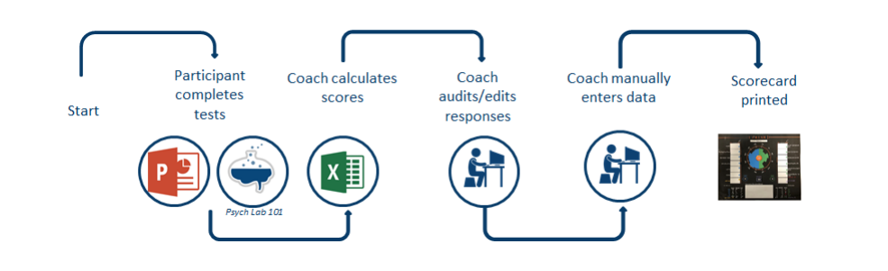

Figure Current process map for cognitive testing.

We propose that the Booz Allen team explore and benchmark other platforms to deliver and score test results from a centralized location. Although the MSBA team is tool-agnostic, we found that NeuroBehavioral Systems (NBS), the organization behind Psych Lab 101, offers clients a proprietary tool called Presentation® to develop and disseminate customized cognitive experiments, all from a single platform. Cognitive tests developed in this platform can be taken on different devices an unlimited number of times within a given time frame. Test results can then be integrated with other participant data in the data repository.

Regardless of the software selected by the Booz Allen team, having a single platform for cognitive testing will reduce time spent on manual data entry, ensure data integrity, and enrich the quality of the human performance data collected during the TAP program for future analysis.

### Recommendation # 3: Leverage Human Performance Data for Advanced Analytics

As previously summarized by the Booz Allen team, the scope of this project involves a very wide but shallow data environment. There are 93 unique variables being captured as part of the TAP program, but because both the capstone and the TAP program started on a very similar timeline, there is not enough data to develop predictive and prescriptive statistical models that can be accurately replicated for later iterations.

Although the Booz Allen team provided the MSBA team with the SWELL dataset on human performance data, the dataset provided has significant differences compared to the data gathered in the TAP program. The SWELL dataset was developed for a different business case, using different HRV variables than those currently gathered by coaches in the program.

The data generated during this pilot effort has the potential to generate powerful insights that can aid in quantifying the success of the program. Because the TAP program is in its early stages, we recommend that the Booz Allen data science team apply regression and classification methods once all of the data generated by different wearable technologies have been integrated into a single data repository.

## Appendix A: Current State Process Map

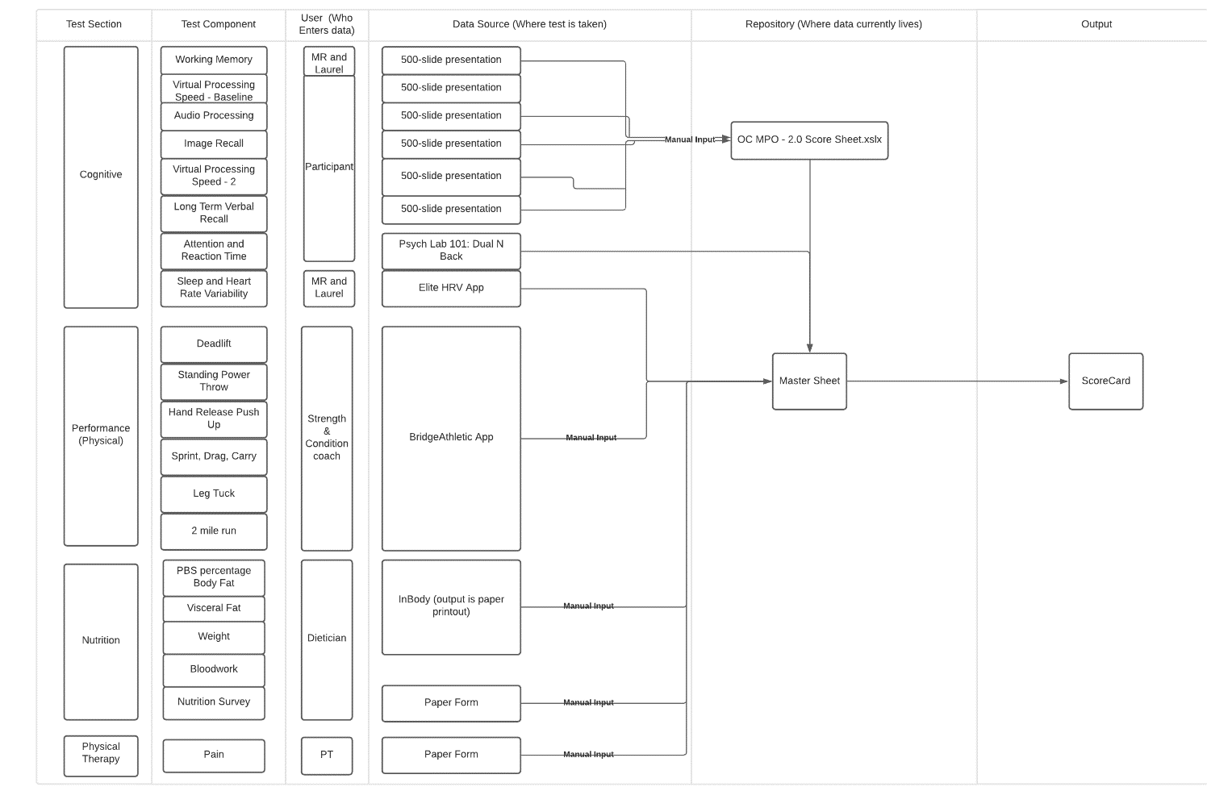

## Appendix B: Actions and AWS Lambda/AWS API Gateway

These screen captures show the action section in Qualtrics XM, AWS Lambda code, and the AWS API gateway flow.

## Appendix C: Power BI Data Model Tables

These screen captures show the relationships between database tables as modeled in Power BI.

PAX Dashboard

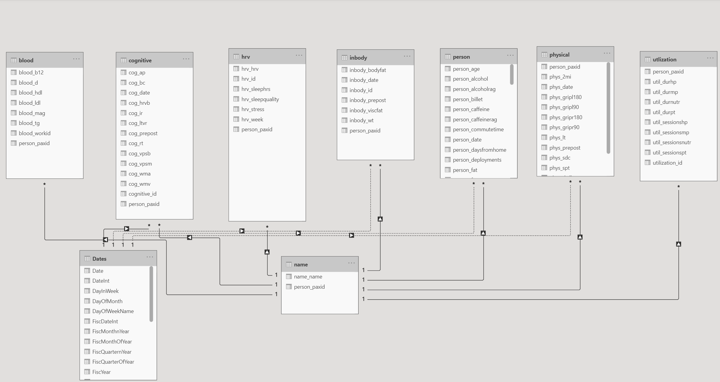

Scorecard

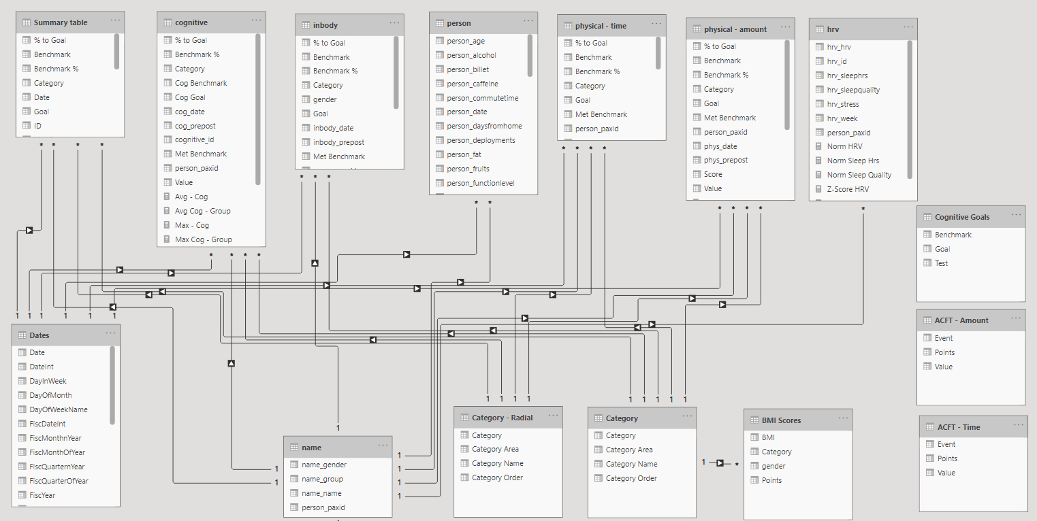

## Appendix D: PAX Dashboard

These screen captures show the PAX Dashboard user interface in Power BI.

Tab 1: PAX Dashboard

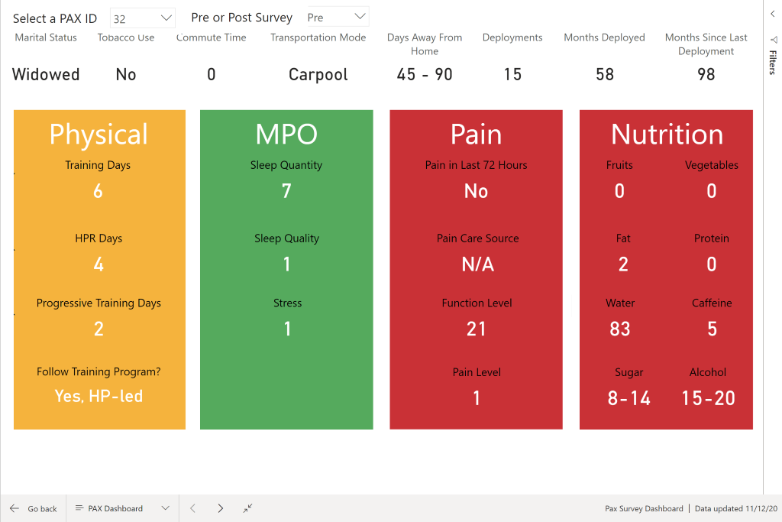

Tab 2: RAG Dashboard

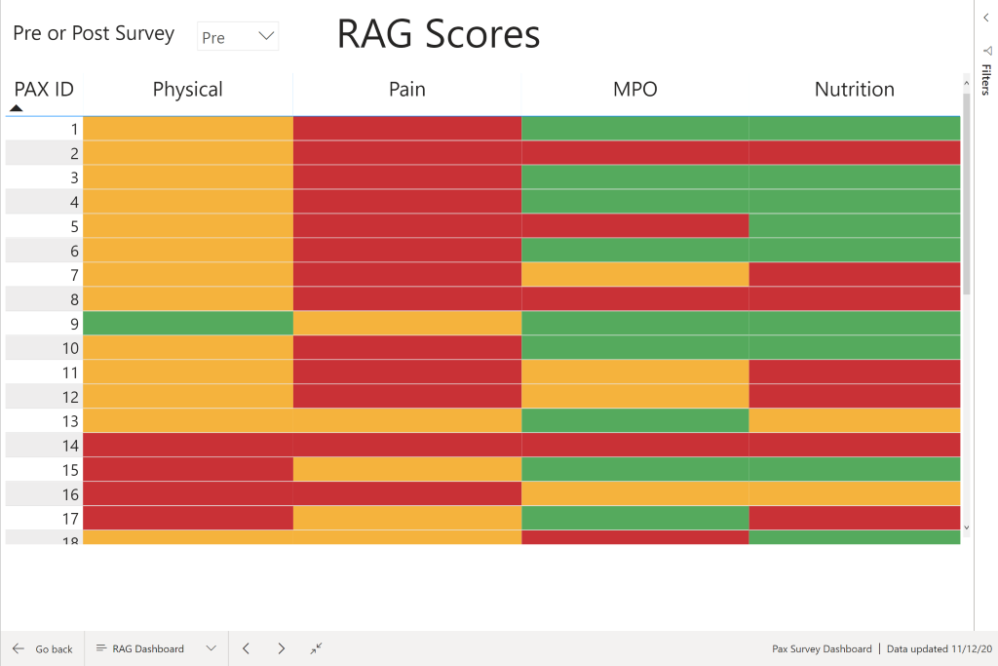

Tab 3: Raw Data

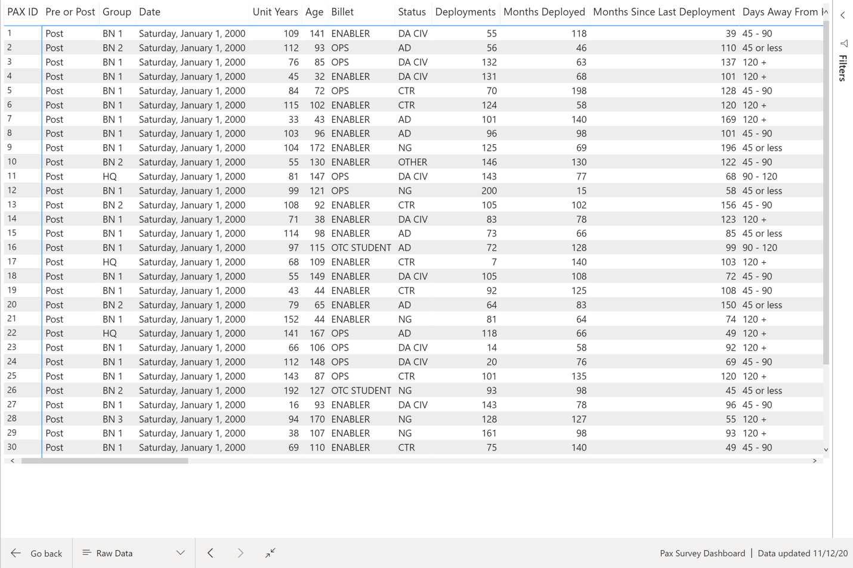

## Appendix E: Scorecard

Initial Scorecard

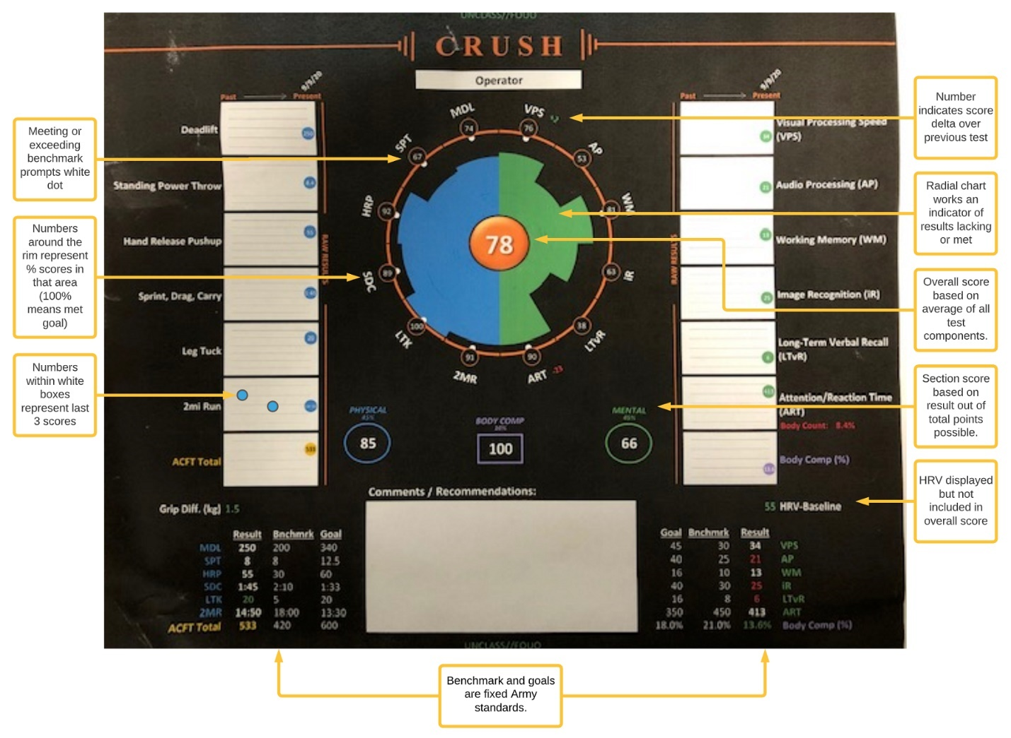

Proposed – Individual Scorecard

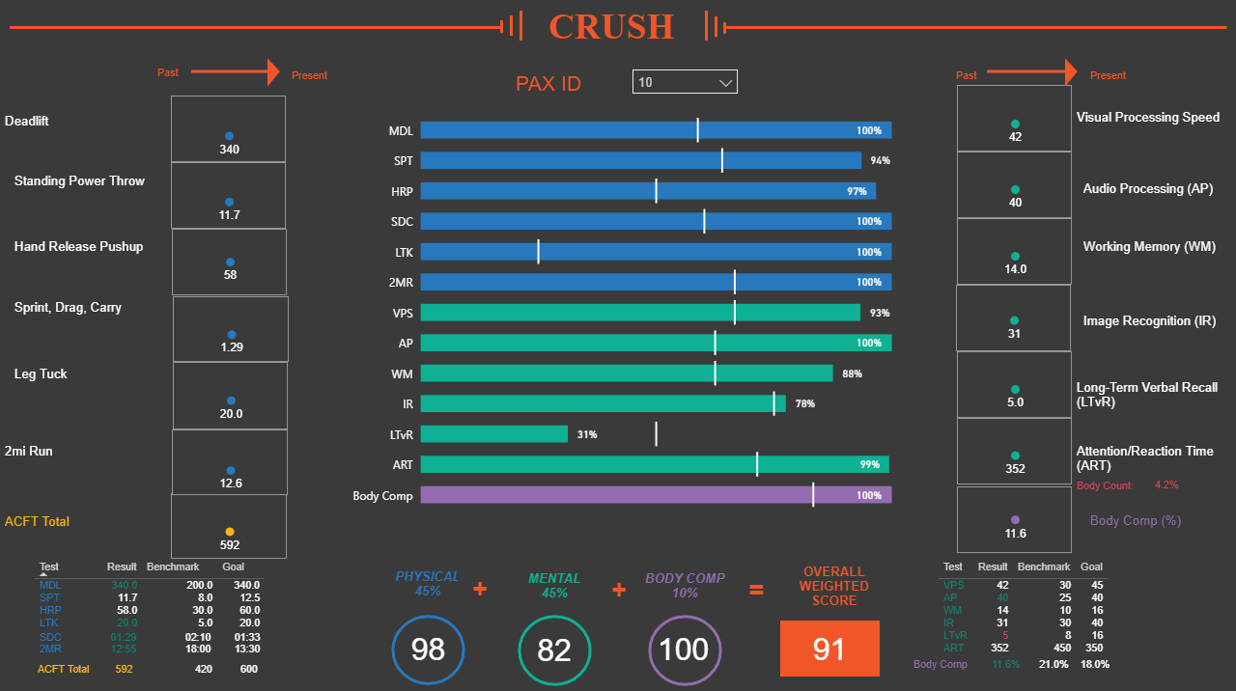

Proposed – Individual Compared to Group/Overall Scorecard

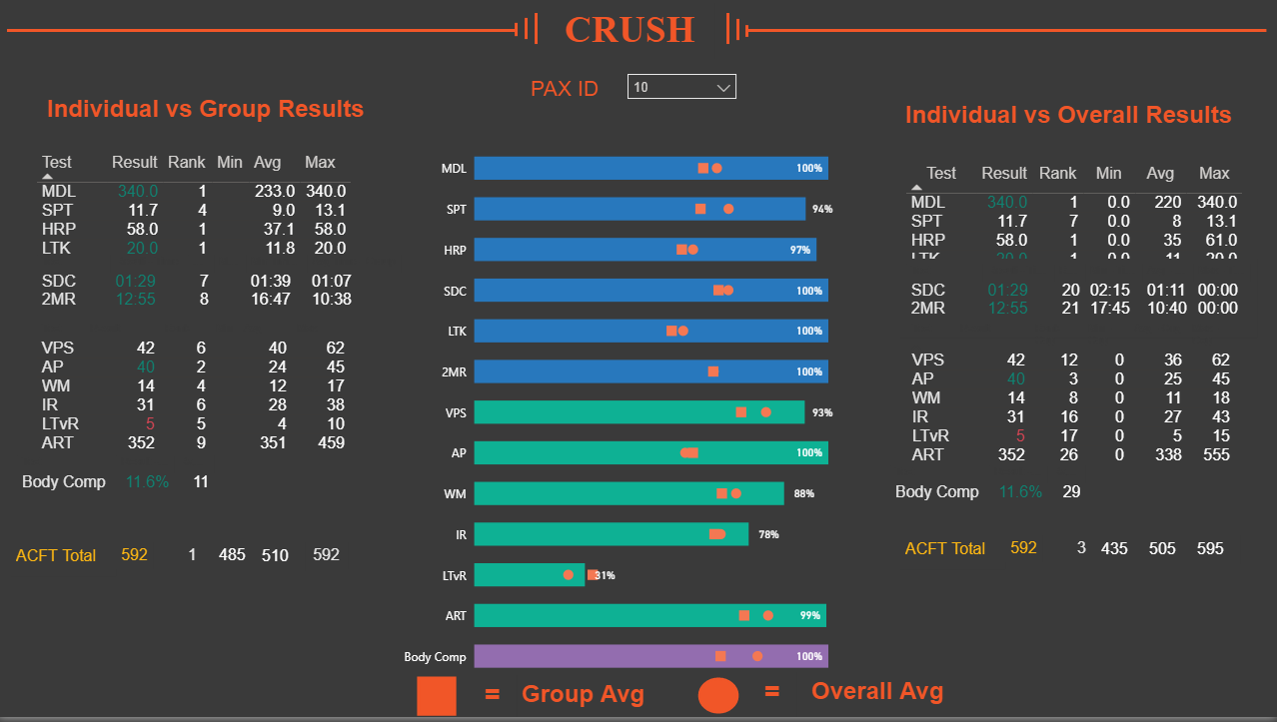

Proposed – TBD Program Insights after completion in December

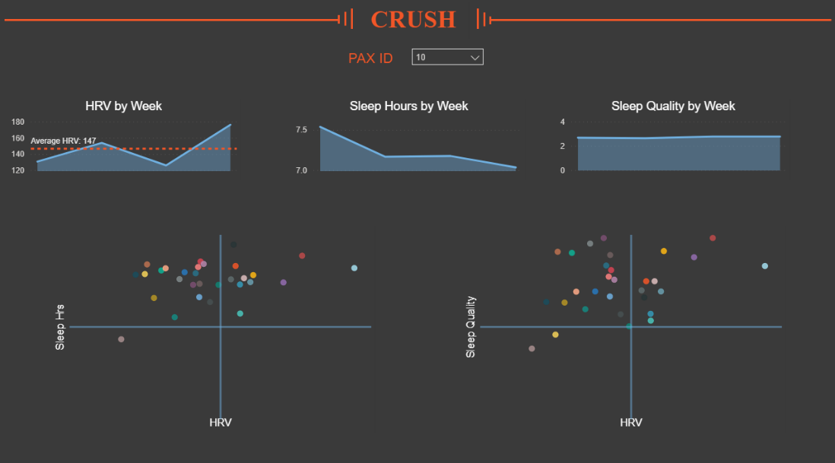

## Appendix F: Coaches Survey Qualtrics Matrix Format

